SECTION A: Multiple-choice questions (1 mark each)
Question 1

Answer: B

Explanation:
The answer of +3 can be determined by assuming oxygen is -2. The ion has an overall charge of 1-, therefore the bromine must balance -2 + -1 => +3

Question 2

Answer: A

Explanation:
The half-equations show the flow of electrons from the zinc. The reaction of zinc is oxidation. Making it the negative electrode and carbon the positive electrode.

Question 3

Answer: C

Explanation:
The manganese is changing from MnO₂ (+4) to Mn₂O₃ (+3)

Question 4

Answer: D

Explanation:
The cell requires H₂ gas, an inert electrode and a solution containing OH⁻ ions.

Question 5

Answer: A

Explanation:
Half-equations occurring are
Fe³⁺(aq) + e Fe²⁺ (aq) and Sn(s) Sn²⁺(aq) + 2e
This shows electrons flowing from the tin to the graphite electrode.

Question 6

Answer: C

Explanation:
The tin electrode loses mass as Sn Sn²⁺ ions

Question 7

Answer: B

Explanation:
Answer can be determined by tracing the species on the right side of the electrochemical series, the closer to the bottom, the stronger the reducing agent.

Question 8

Answer: C

Explanation:
C is the only option that is balanced correctly.

Question 9

Answer: D

Explanation:
Whether acidic or alkaline, the overall equation in a hydrogen fuel cell is the formation of water.

Question 10

Answer: A

Explanation

The nature of electrodes needing to be porous and catalytic usually makes fuel cells expensive.

SECTION B: Short-answer questions

Question 1 (13 marks)
a. i. V₂O₅ +5 ii. VO₃⁻ +5 4 marks

iii. V₂O₄ +4 iv. VO₂⁺ +3

b. i. VO₂⁺ + 2H⁺ + e VO²⁺ + H₂O 1 mark

ii. VO²⁺ + 2H⁺ + e V³⁺ + H₂O 1 mark

iii. both reduction 2 marks

c. i. oxidation state change of the sulfur +4 to +6 1 mark
ii. Identify the reducing agent SO₂ 1 mark

d. i. NO₃⁻(aq) + 4H⁺(aq) + 3V²⁺aq) NO(g) + V³⁺(aq) + H ₂O(l) 1 mark

ii. Identify the oxidising agent in this reaction NO₃⁻(aq) 1 mark

iii. Determine the theoretical voltage 0.96 - -0.26 = 1.22 V 1 mark

Question 2 (8 marks)

Complete the template below to show the half-reactions occurring in this cell. Show
- the polarity of the electrodes
- possible solutions in each cell
- the material the electrode is made from
- direction of electron flow
- ion movement on salt bridge *

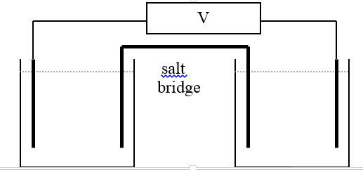
- + *
Co graphite

CoCl₂(aq) K₂Cr₂O₇²⁻ (aq)/H⁺

*
Oxidation half equation Reduction half-equation

Co(s) Co²⁺(aq) + 2e * Cr₂O₇²⁻ (aq) +14H⁺(aq) + 6e 2Cr³⁺(aq) + 7H₂O(l) *

Overall equation Cr₂O₇²⁻ (aq) +14H⁺(aq) + 3Co(s) 2Cr³⁺(aq) + 3Co²⁺(aq) + 7H₂O(l) *

Theoretical cell voltage 1.36- - 0.28 = 1.64 V *

Salt bridge: K⁺ flows into dichromate and NO₃⁻ flows into Cobalt half-cell *
8 marks

Question 3 (6 marks)
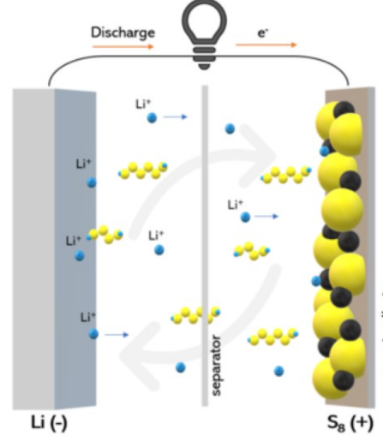
e
- +

a. Anode: Li Li⁺ + e 1 mark

Cathode: S₈ + 16e 8S²⁻ 1 mark

Overall equation: 16Li + S₈ 8Li₂S 1 mark

b. i. the direction of electron flow 1 mark
see diagram
ii. the polarity of the electrodes. 1 mark

c. -3.04 – -2.15 = 0.89 V 1 mark

Question 4 (13 marks)
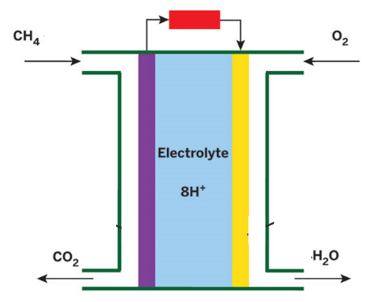
- +

a. Cathode reaction : O₂(g) + 4H⁺(aq) + 4e 2H₂O(l)
anode reaction: CH₄(g) + 2H₂O(l) CO₂(g) + 8H⁺(aq) + 8e

Overall equation: CH₄(g) + 2O₂(g) CO₂(g) + 2H₂O(l) 3 marks

b. see diagram 2 marks

c. i. The electrodes not to allow reactant gases to pass through so they are microporous and they need to catalyse the reaction, hence they often contain amounts of expensive metals. 2 marks

ii. Fuel cell – continuous supply of reactant
Primary cell – limited amount of reactant. 1 mark

d. The sustainability hinges upon the sourcing of methane. It it comes from natural gas, the cell offers little improvement in current sustainability – methane is scarce and CO₂ is produced. If the methane is obtained from biodigestion of waste then this is better – it is not a scarce fuel and it is using up waste. The use of renewable feedstock is a relevant green chemistry principle. 3 marks

e. n(methane) = 4/16 = 0.25 mol
n(e) = 1/8 n(methane) = 0.03125 mol
charge = 0.03125 x 96500 = 3000 Q 2 marks

